Digital Signal Processing

Laboratory

(EC- 3096)

Spring- 2023-2024


OPEN ENDED EXPERIMENT- I

School of Electronics Engineering

KALINGA INSTITUTE OF INDUSTRIAL TECHNOLOGY

(Deemed to be University)

BHUBANESWAR

Experiment Number | 09
Date of Experiment | 14/03/2024
Date of Submission | 21/03/2024
Name of the students | ABHIJEET RISHOO, ADITYA KUMAR
 | ADTIYA RAJ, ADWAY CHAKRABORTY
Roll Numbers | 2104002,2104003,2104004,2104005
Section | ETC-1

AIM OF THE EXPERIMENT: Removal of echo in audio signal and measuring its frequency and observing its waveform using MATLAB.

EQUIPMENT AND SOFTWARE REQUIRED:

The software required is MATLAB R2017

THEORY:

Echo is a phenomenon where a delayed and distorted version of an original sound or electrical signal is reflected back to the source. If a reflected wave arrives after a very short time of direct sound, it is considered as a spectral distortion or reverberation. However, when the leading edge of the reflected wave arrives a few tens of milliseconds after the direct sound, it is heard as a distinct echo.

How is echo generated?

A significant problem in communications is the generation of echoes. The echoes arise for a number of reasons, with the primary reason being an impedance mismatch. The impedance mismatch occurs when the two- wire network meets the four-wire network; this interface is known as the hybrid. This impedance mismatch causes some of the signal energy to be returned to the source as an echo. The delays between primary and echo signals are directly related to the transmission distance.

CODE:
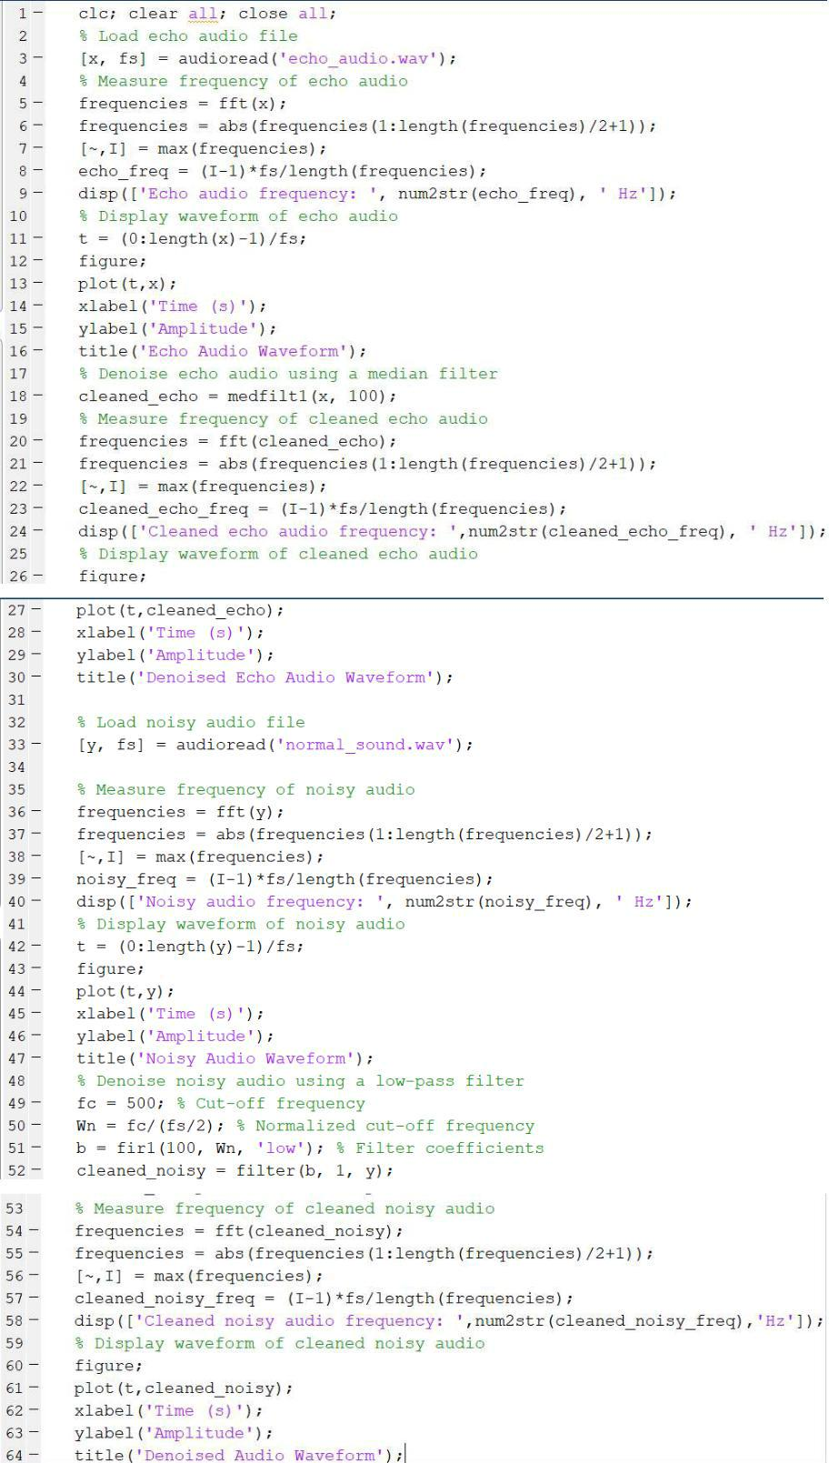

OUTPUT/GRAPHS:
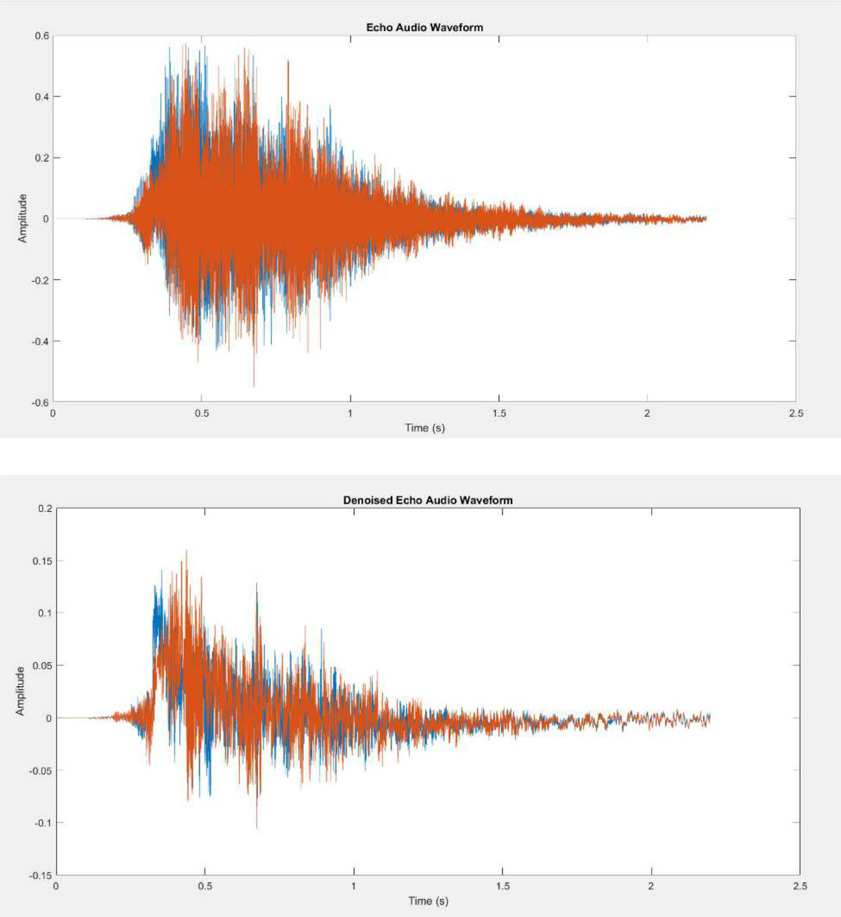
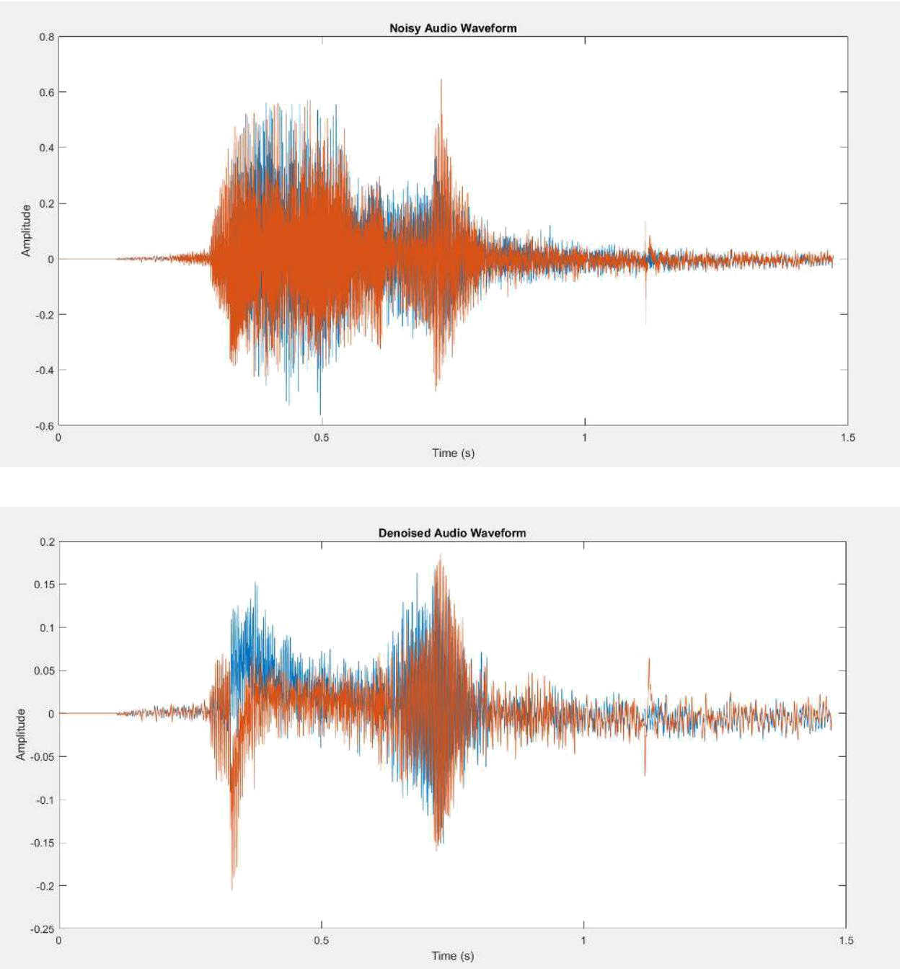

DISCUSSION / INTERFERENCE OF THE EXPERIMENT:
The frequencies of echo audio and noisy audio are compared and the waveforms were observed. The amplitudes of original audio and denoised audio are changed.
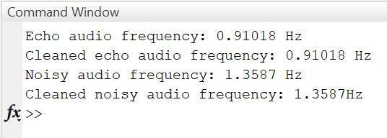

CONCLUSION:

We have successfully compared and removed the echo in audio signal and measured its frequency and observed its waveform using MATLAB.

